Naming the constraints

Constraint_columnName_TableName

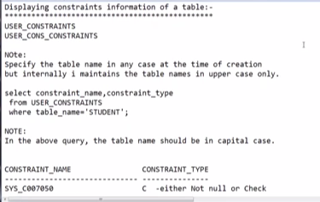

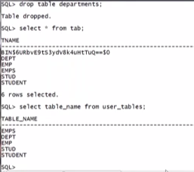

SQL> -- select * from tab; gives the information of tables from recycle bin also.

SQL> --select table_name from user_tables; doesnot display the deleted tables information.

select constraint_name from user_constraints; available constraints will be displayed.

select constraint_name from user_constraints where table_name = 'student';

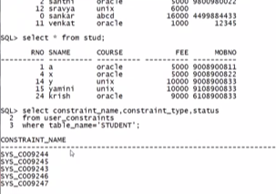

Constraints showing in some code, so we need to give some names to understand better on which column it is defined.

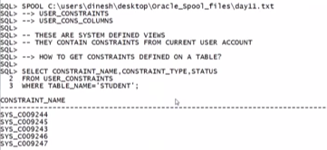

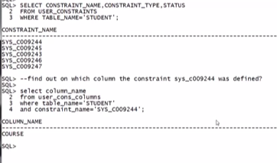

We can find the constraint on which column it is defined by using above command.

SQL> select constraint_name from user_constraints where table_name = 'student';

no rows selected

SQL> select constraint_name, status from user_constraints where table_name='stud';

no rows selected

SQL> select constraint_name, status from user_constraints where table_name='STUD';

CONSTRAINT_NAME STATUS

------------------------------ --------

SYS_C007021 ENABLED

SYS_C007022 ENABLED

SYS_C007023 ENABLED

SYS_C007024 ENABLED

SYS_C007025 ENABLED

SYS_C007026 ENABLED

SYS_C007027 ENABLED

SYS_C007028 ENABLED

SYS_C007029 ENABLED

SYS_C007030 ENABLED

10 rows selected.

SQL> select constraint_name, constraint_type, status from user_constraints where table_name='STUD';

CONSTRAINT_NAME C STATUS

------------------------------ - --------

SYS_C007021 C ENABLED

SYS_C007022 C ENABLED

SYS_C007023 C ENABLED

SYS_C007024 C ENABLED

SYS_C007025 C ENABLED

SYS_C007026 C ENABLED

SYS_C007027 C ENABLED

SYS_C007028 C ENABLED

SYS_C007029 P ENABLED

SYS_C007030 U ENABLED

10 rows selected.

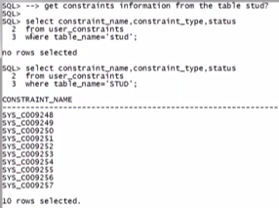

Instead of sys defined numbers , we can define user defined constraint names.

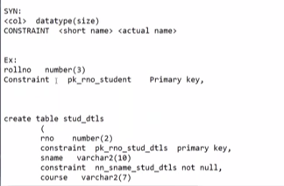

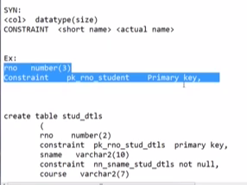

SQL> --create a table and creating user defined constraint names.

SQL> create table s

2 (

3 rno number(2) constraint pk_rno_s primary key,

4 constraint ck_rno_s check(rno between 1 and 99),

5 sname varchar2(10) constraint nn_sname_s not null,

6 );

)

*

ERROR at line 6:

ORA-00904: : invalid identifier

SQL> ed

Wrote file afiedt.buf

1 create table s

2 (

3 rno number(2) constraint pk_rno_s primary key,

4 constraint ck_rno_s check(rno between 1 and 99),

5 sname varchar2(10) constraint nn_sname_s not null

6* )

SQL> /

Table created.

SQL> insert into s values(1, 'scsr');

1 row created.

SQL> select constraint_name, constraint_type, status from user_constraints where table_name='s';

no rows selected

SQL> select constraint_name, constraint_type, status from user_constraints where table_name='S';

CONSTRAINT_NAME C STATUS

------------------------------ - --------

NN_SNAME_S C ENABLED

CK_RNO_S C ENABLED

PK_RNO_S P ENABLED

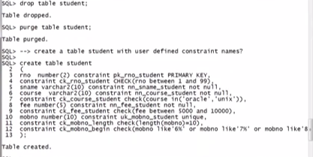

SQL> insert into s values(2, 'scsr');

1 row created.

SQL> insert into s values(2, 'sai');

insert into s values(2, 'sai')

*

ERROR at line 1:

ORA-00001: unique constraint (SYSTEM.PK_RNO_S) violated

SQL> insert into s(rno) values(3);

insert into s(rno) values(3)

*

ERROR at line 1:

ORA-01400: cannot insert NULL into ("SYSTEM"."S"."SNAME")

* Here we can find easily what is the error, acc. To constraint name.
* 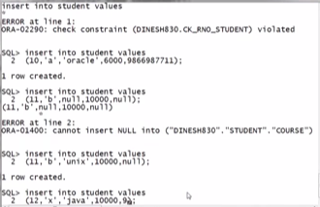
* 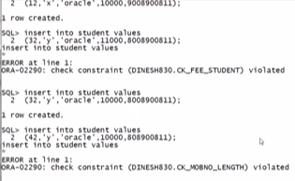

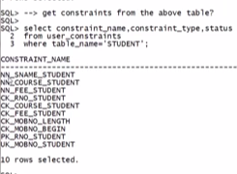

We should not repeat constraint name in same user account